Clay for Dementia Spring workshops
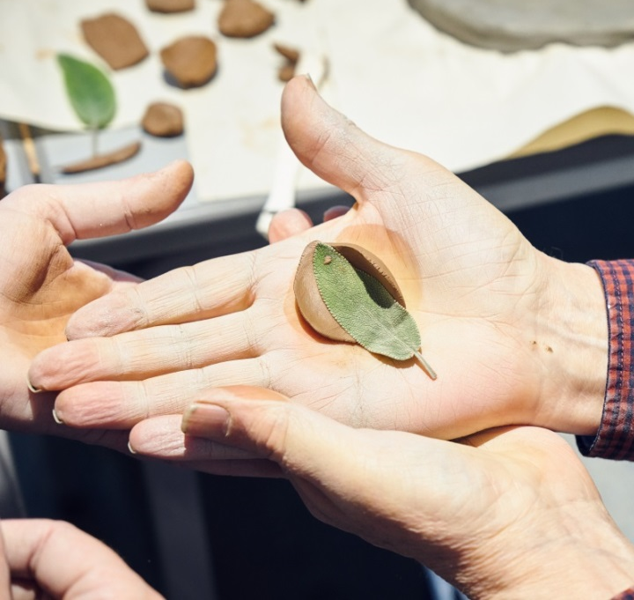
A programme of six sessions for people affected by early stage dementia
and their companions
When: Thursday mornings
4th, 11th, 18th, 25th April
2nd, 9th May
10.45 am-12.30pm
Garden Museum
Lambeth Palace Road
London SE1 7LB

Led by ceramic artist Katie Spragg and supported by our friendly volunteers.
These relaxing weekly sessions for people affected by early stage dementia and their companions provide an introduction to working with clay.

Based in the beautiful setting of the Garden Museum.
Katie will demonstrate techniques to create objects and sculptures from clay, inspired by nature and the museum collection. The pieces created will be fired in a kiln ready to take home at the end of the workshops.
The sessions are free of charge.
Places are limited for these popular sessions so early registration is recommended and participants and their companions registering are invited to attend all sessions. Tea, coffee and biscuits are provided. Arrival from 10.30am.
No prior experience necessary. The venue is fully wheelchair accessible.
To register or for further information, please contact: Janine Nelson, Head of Learning
Email: janine@gardenmuseum.org.uk Tel: 020 7401 8865
Garden Museum, Lambeth Palace Road, London SE1 7LB
www.gardenmuseum.org.uk Registered Charity No. 1088221
FOR DIRECTIONS ON HOW TO GET TO THE GARDEN MUSEUM – Please see next page

Photo credit Jon Holloway
GETTING THERE
The Garden Museum is next door to Lambeth Palace, on the south bank of the Thames next to Lambeth Palace and opposite Tate Britain.
BY TRAIN/TUBE: The nearest tube stations are Westminster, Waterloo, Lambeth North or Vauxhall. The nearest mainline stations are Victoria, Waterloo and Vauxhall.
BY BUS: You can take the 3, 344, 360, 507 or C10 bus directly to the Museum. Contact Transport for London for the latest travel updates. See map below.
BY CAR: Paid on-street parking spaces are located at Lambeth High Street and Pratt Walk. Paid car parking can be found at the Novotel Hotel and on Black Prince Road.

